EXP. NO: 16 SIMULATION AND ANALYSIS OF UNIFORM AND NON-UNIFORM
QUANTIZATION USING MATLAB

PROGRAM:
clc; clear; close all;
t = 0:0.001:1;
x = sin(2*pi*5*t);
L = 8; mu = 255;
xu = round((x+1)*3.5)/3.5-1;
xn = round((sign(x).*log(1+mu*abs(x))/log(1+mu)+1)*3.5)/3.5-1;
subplot(3,1,1); plot(t,x); title('Original Signal'); grid on;
subplot(3,1,2); stairs(t,xu); title('Uniform Quantization'); grid on;
subplot(3,1,3); stairs(t,xn); title('Non-Uniform Quantization'); grid on;

WAVEFORM:

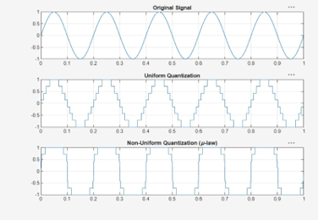

OUTPUT:
